**CONTENTS PAGE NO**

1. **INTRODUCTION** 
   1. Overview
   2. Purpose
2. **PROBLEM DEFINITION & DESIGN THINKING**
   1. Empathy Map
   2. Ideation & Brainstorming Map
3. **RESULT**
4. **ADVANTAGES & DISADVANTAGES**
5. **APPLICATIONS**
6. **CONCLUSION**
7. **FUTURE SCOPE**
8. **APPENDIX**
   1. Source Code

**INTRODUCTION**

The main objective of News App is to provide the users with easy access to the latest news from a variety of reliable sources for user-friendly and efficient manner. This app should aim to offer a clean and organized interface, with a focus on delivering news articles quickly and efficiently.

* 1. **Overview:**
* Providing a personalized experience: The News app should allow users to customize their news feed based on their interests, location, or other preferences.
* Offering real-time updates: This app should be updated frequently to ensure that users have access to the latest news as it happens.
* Ensuring accuracy and reliability: It should only source news from credible and reliable sources to ensure that users receive accurate and trustworthy information.
* Enhancing engagement: This app should provide users with the ability to interact with news stories by commenting, sharing, or reacting to articles.
  1. **Purpose:**
* Providing users with a convenient and efficient way to access news articles from different sources.
* Delivering news stories in real-time to ensure users stay up-to-date on current events.
* Providing a platform for users to engage with news stories, share articles with others, and provide feedback or comments.
* Offering a platform for publishers to distribute their content and reach a wider audience.

**PROBLEM DEFINITION & DESIGN THINKING**

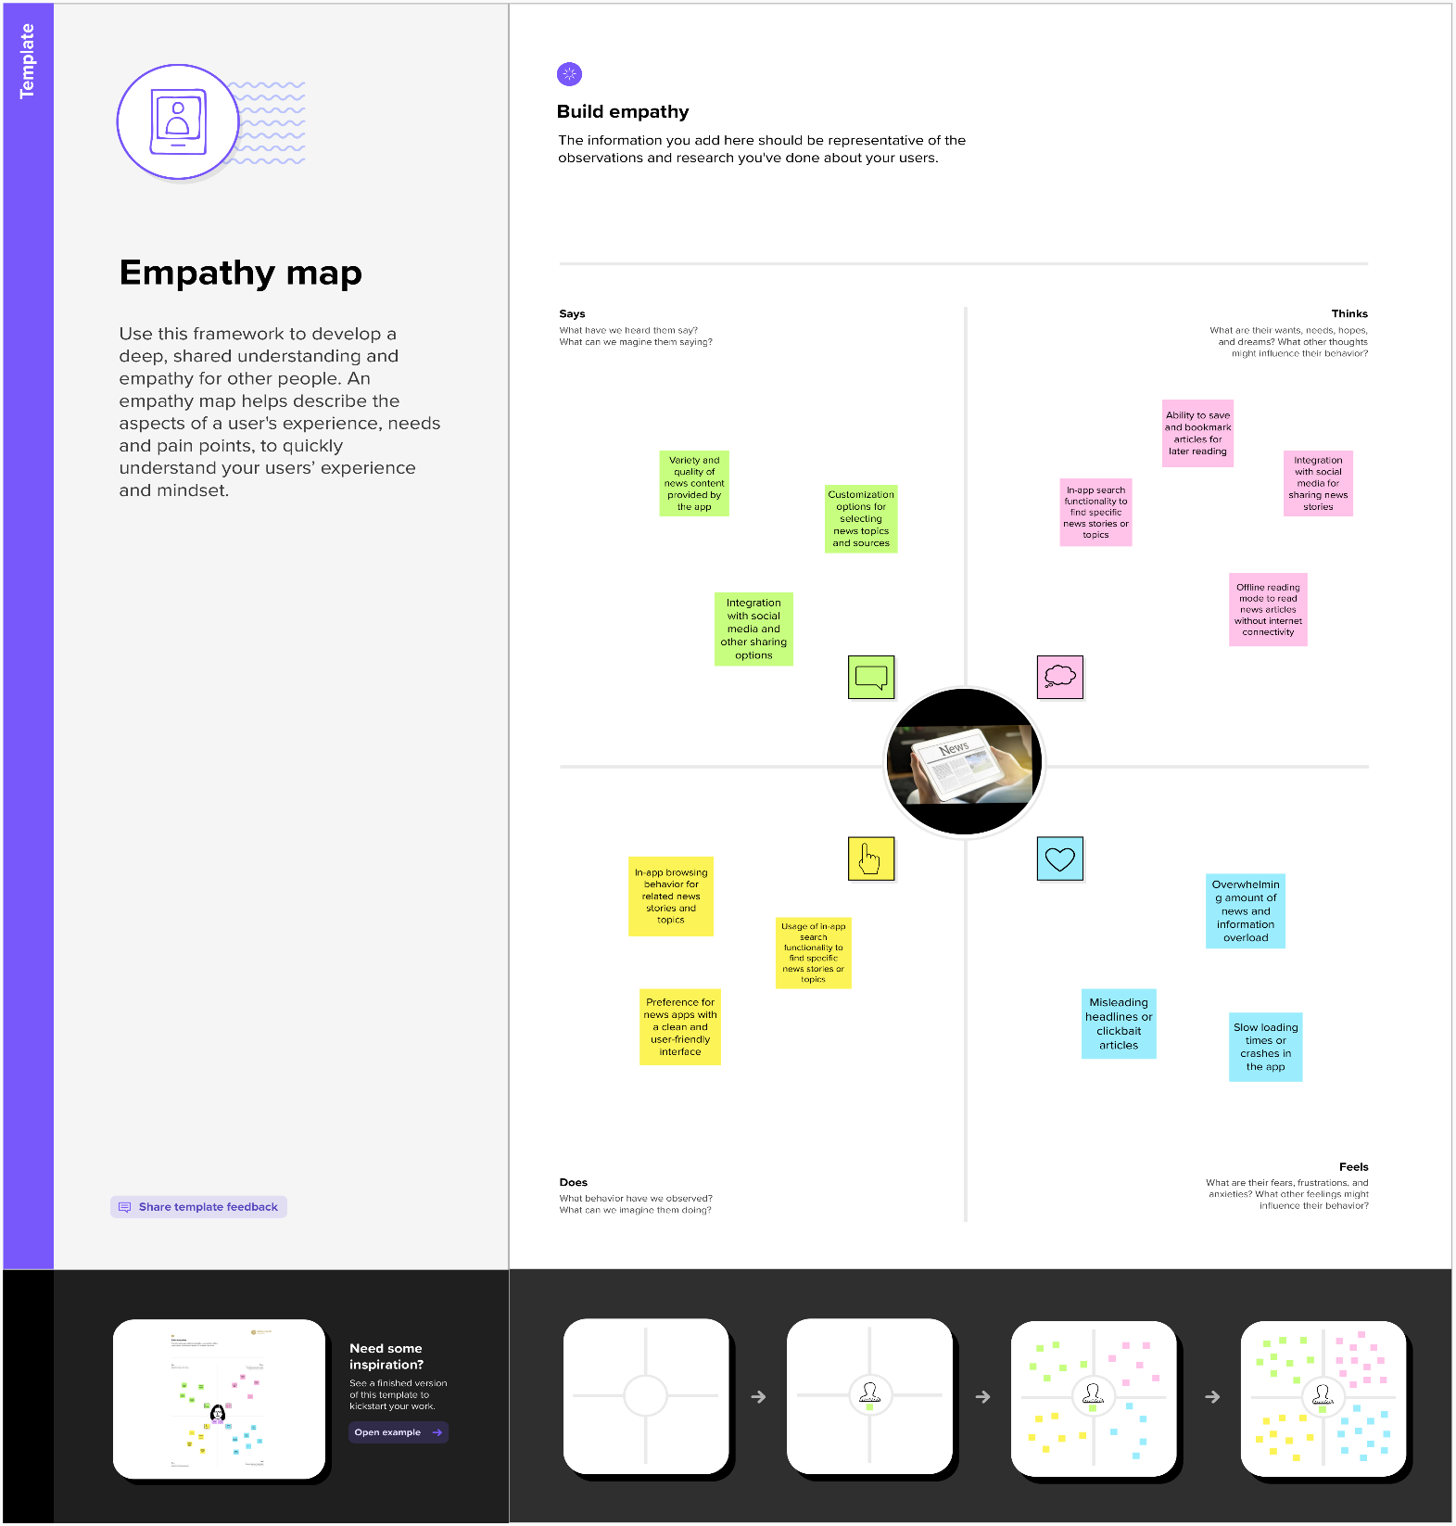**2.1 Empathy Map:**

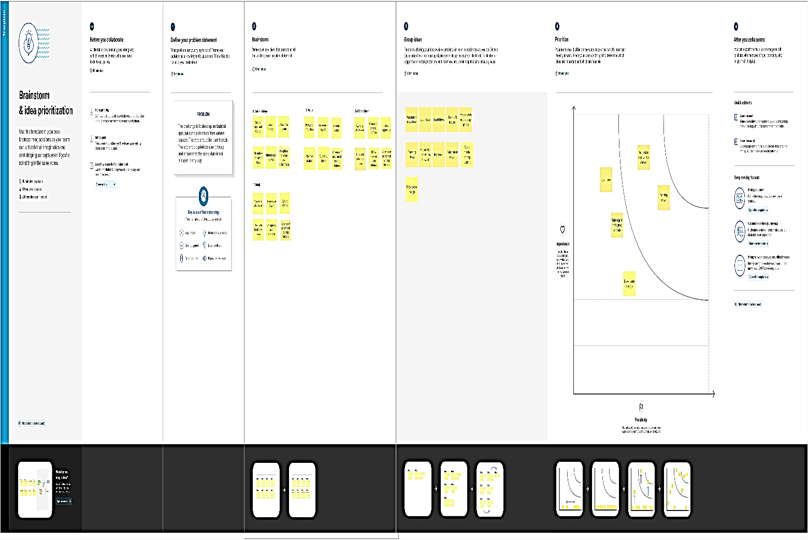**2.2 Ideation & Brainstorming Map:**

**RESULT**

**Sign in Page:**

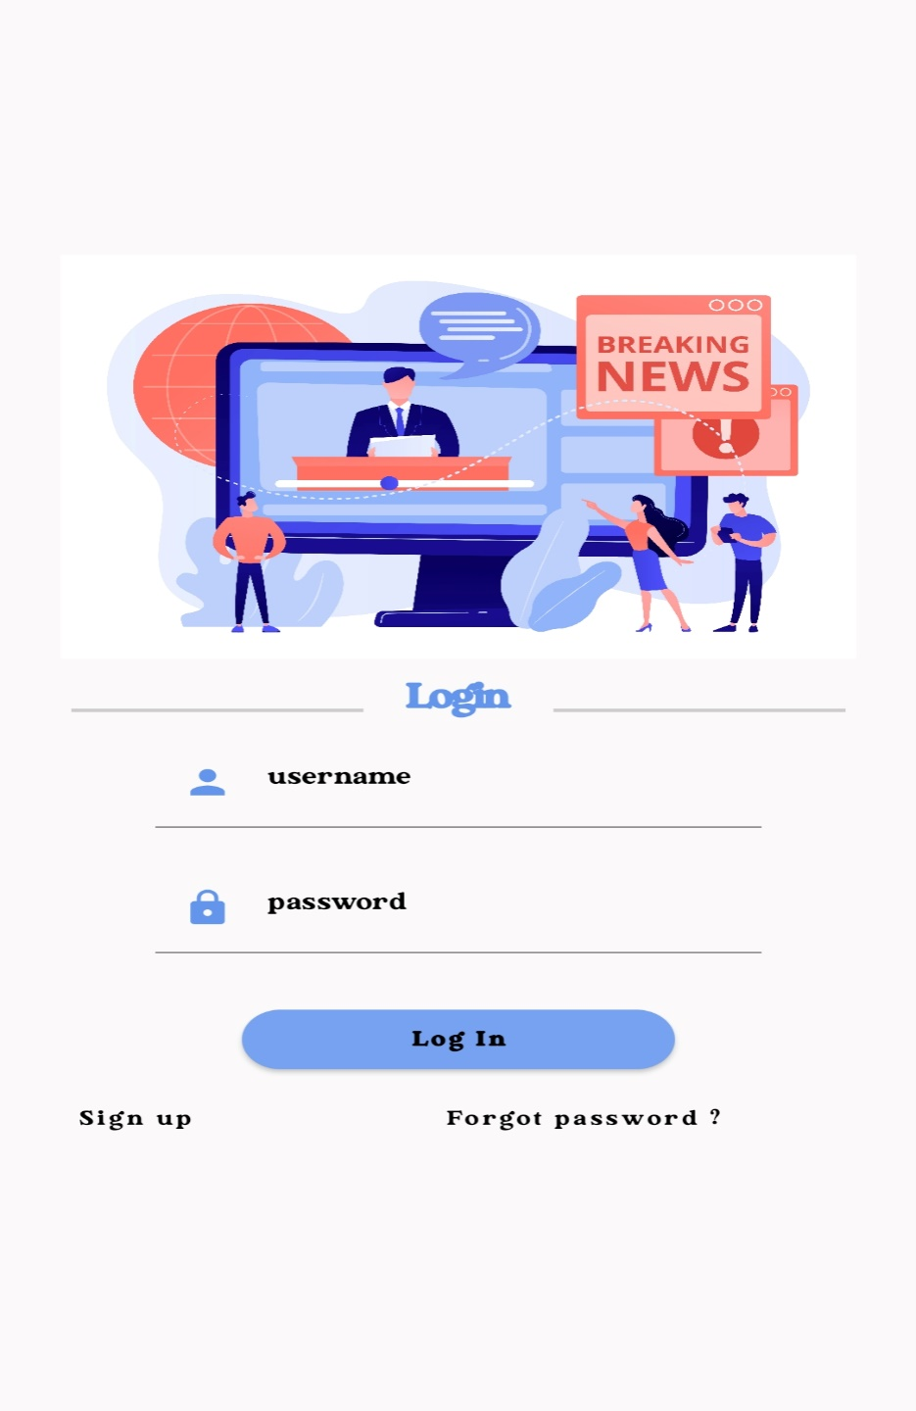

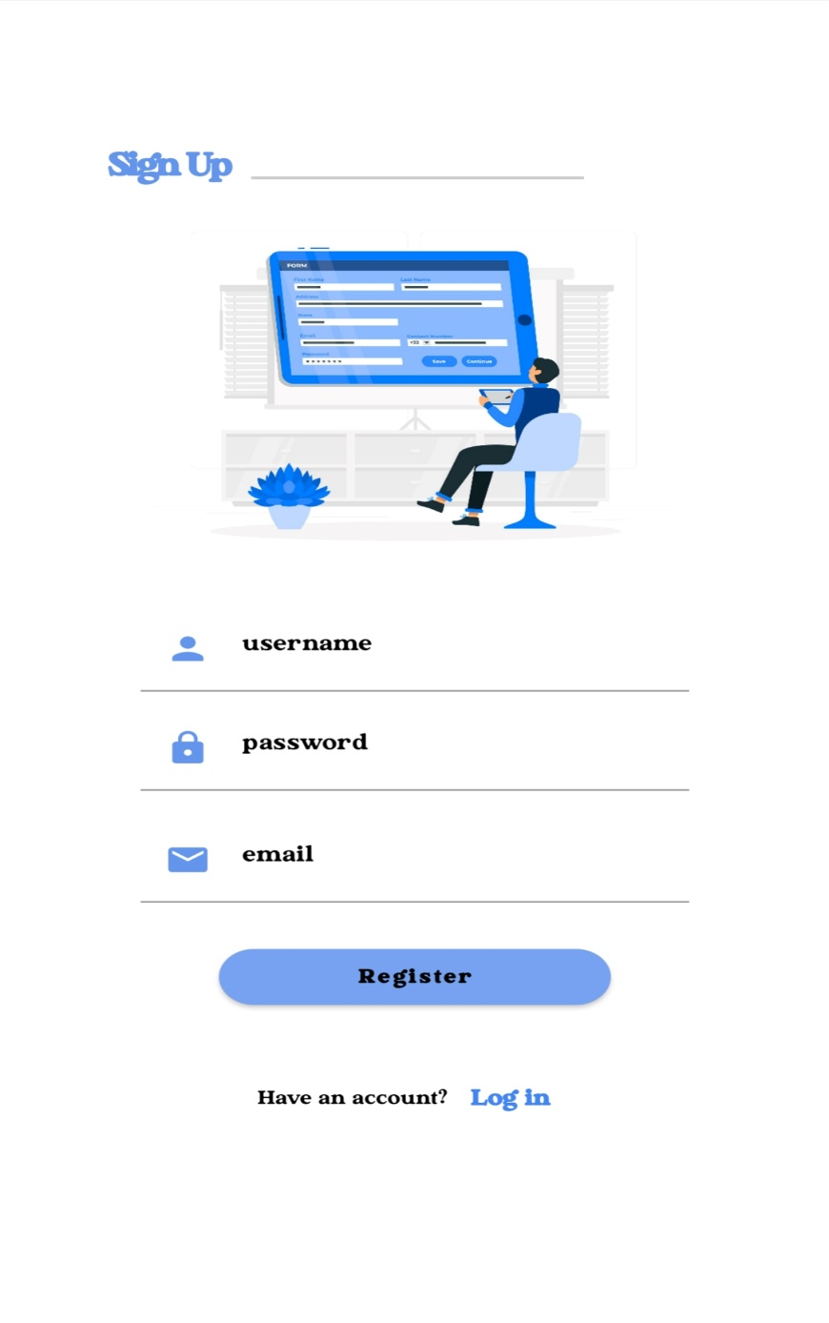**Sign up page:**

**Home Page:**



**News Page:**



**ADVANTAGES & DISADVANTAGES**

* 1. **Advantages:**
* Convenience: A news app provides users with a quick and convenient way to access news articles from multiple sources in one place, without having to navigate through various websites or apps.
* Personalization: Users can customize their news feed by selecting topics or categories of interest, ensuring that they only receive news that is relevant to them.
* Real-time updates: A news app can deliver news stories in real-time, ensuring that users stay up-to-date on current events as they unfold.
* Privacy: Unauthorized person cannot access your app without enter correct username and password.
  1. **Disadvantages:**
* User engagement: A news app can provide users with features such as commenting, sharing, and saving articles, which can encourage engagement and interaction with the app.
* Technical issues: As with any app, technical issues such as bugs, crashes, or slow loading times can frustrate users and damage the app's reputation.
* Limited news sources: If the app only pulls news from a select few sources, users may not receive a diverse range of perspectives on news events. This could lead to a perception of bias or limited coverage.
* Limited functionality: If the app only provides basic features such as signing up and listing news articles, it may not be competitive with other news apps that offer more advanced features such as multimedia content, social sharing, or personalization.

**APPLICATIONS**

* General news: A news app can be used to deliver general news articles from a variety of sources, covering topics such as politics, world news, sports, and entertainment.
* Social news: A news app can incorporate social media features to allow users to share news articles with their social network or engage in discussions around specific news events.
* Education: A news app can be used in an educational setting to provide students with access to current events and news articles relevant to their coursework or research.
* Business: A news app can be used in a business setting to provide employees with access to news articles and updates related to their industry or company.
* Travel: A news app can provide users with access to news articles and updates related to their travel destination, including local news, events, and travel tips.
* Politics: A news app can be used in a political setting to provide users with access to news articles and updates related to politics, elections, and government policies.

**Conclusion**

We conclude that the News app would feature a sign-up and sign-in page, as well as a news page where articles are listed with current updates. Additionally, the app would allow users to view short notes on news articles when they select a particular news item. However, there are some potential limitations to this app, such as limited news sources, basic functionality, and lack of offline access. To improve the app, you plan to add the ability to save news articles, show brief news articles when a user selects a particular news item, improve the user interface, and show news articles based on categories. It can be applied in various areas where there is a need for access to up-to-date news and information, including general news, local news, niche news, social news, education, business, travel, and politics. The UI will be improved to make the app more visually appealing and user-friendly. The News app will not have offline access initially, but this will also be added in a future update.

**Future Scopes**

In future adding more sources to provide users with a wider range of news articles to choose from. To make the app more engaging for users and adding personalization features. Adding features that allow users to share news articles with their friends, or engage in discussions around specific news events. Adding audio and video clip features to the app for more user-friendly. To add more local news articles to provide users with up-to-date information on events and news in their local area and allow users to access news articles even when they are not connected to the internet.

**APPENDIX**

* 1. **Source Code:**